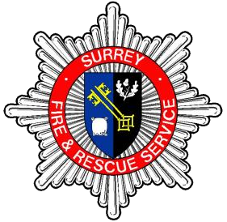
THE ROLE

Learning and Development - Fire Ground and face Fit Technician

Department: Learning and Development (L&D)

Grade/Rank: PS7

Responsible to: Live Fire Lead Instructor

Base Location: Wray Park Centre, Reigate

Job Purpose:

This role supports the delivery of Live Fire Training and Face Fit Testing of Surrey Fire and Rescue personnel.

Main Duties and Responsibilities:

The below profile describes the general nature of work performed at this level as set out in the job family. It is not intended to be a detailed list off all duties and responsibilities which may be required. The role will be further defined by annual objectives. Surrey Fire and Rescue Service reserve the rights to review and amend the job families on a regular basis.

Ensuring that venues, PPE and equipment are set up ready for training to commence, including maintaining consumables to the correct level and assisting Live Fire Instructors in delivery of training.

Responsible for Face Fit testing of personnel for Breathing Apparatus and Half Masks, ensuring sufficiently trained personnel are available to meet demands.

Produce reports and use computer systems to test, monitor and record outcomes.

Ordering of supplies and consumables to ensure continuous training to be able to take place.

Maintenance, cleaning and preparing of Live Fire facilities and equipment

Liaise with Property department and contractors for maintenance schedules for Live Fire and associated training facilities.

Must be willing to travel to other locations where equipment needs to be maintained across the county. This position involves a degree of physical activity in terms of lifting and carrying items of equipment (e.g. compressed air cylinders). A measure of physical fitness is required which will be assessed by means of a medical questionnaire.

Our Core Values and Behaviours:

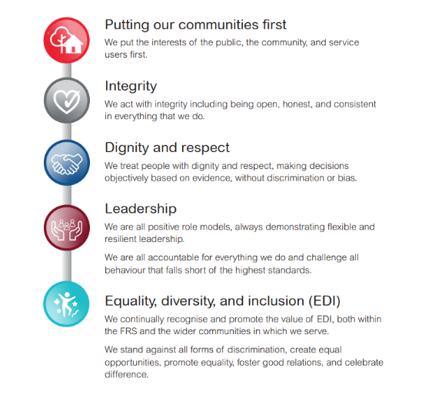

THE PERSON

Learning and Development Live Fire Technician

Qualifications

- IOSH - Managing Safely
- Instructor Qualifications in technical subject areas as directed

Knowledge and Experience

- Experience of use and maintenance of Breathing Apparatus.
- Experience of Face Fitting.
- Experience of working within a team, communicating effectively, and demonstrating professionalism.
- Knowledge of the legislation relating to Health and Safety in the Workplace.

Skills and Abilities

- Be organised, reliable, focused and practically minded
- Able to be open and flexible towards change, leading participation in devising solutions to problems.
- Ability to adopt different methods and innovative ways to gain support and influence internal and external stakeholders.
- A proactive approach to work, and the achievement of a consistently high standard, displaying high personal and professional standards and challenging poor behaviour and performance.
- Ability to work effectively with technology and able to demonstrate competence with basic software or IT equipment.
- A demonstrable commitment to continuous professional development or the attainment of personal goals.

Equal Opportunities

- Understanding of and commitment to Inclusion & Equality in the workplace.
- Ability to demonstrate a respect for others and willingness to challenge.
- Supporting your colleagues in the Learning and Development department to deliver training in their areas of responsibility.
- Understanding of and commitment to Inclusion & Equality in the workplace.
- Ensure adequate consumables, equipment and PPE for students and instructors within your area of training responsibility.
- Carry out Health and Safety risk assessments for internal and external training venues.
- Establish and maintain effective working relationships with internal and external stakeholders to research, gain knowledge and develop skills to improve performance.
- Evaluate and improve Learning and Development provision.

