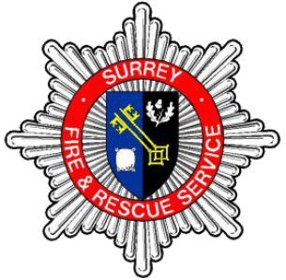 | THE ROLE  Operational Risk Support Co Ordinator

Department: | Protection
Grade/Rank: | Watch Commander equivalent (Base rank kept for monthly operational shifts)
Responsible to: | Station Commander – Protection Support
Location: | In County
Responsible for: | Not Applicable

Job Purpose:

To protect and save life, property and the environment by contributing to the protection of people and making communities safer by:

- Managing people and their activities to ensure effective service delivery.
- Supervising and delivering operational risk reduction programmes.
- Managing the maintenance and response of the emergency service.
- Providing leadership and support in the workplace

Working within the community and operational teams to prepare for emergencies occurring, minimise their impact when they do and intervene effectively when required. All of this benefitting the community and making Surrey Safer.

Working with Response and Protection teams to ensure the Site Specific Risk
Information (SSRI) systems are up to date with regards to the built environment. Supporting improved firefighter safety and recording of significant information for crews.

Our Core Code of Ethics
Surrey Fire and Rescue Service has adopted the national Core Code of Ethics for Fire and Rescue Services in England. This has been developed in partnership with the National Fire Chiefs Council, Local Government Association, and the Association of Police and Crime Commissioners to support a consistent approach to ethics, including behaviours, by fire and rescue services in England.

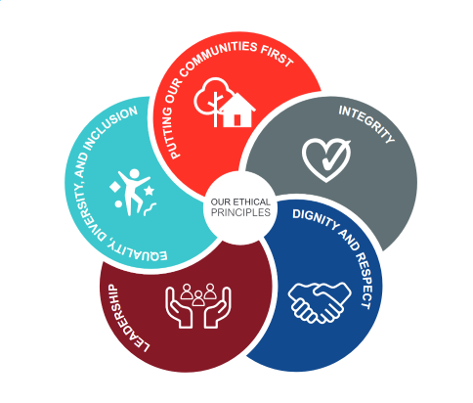 | Putting our communities first  We put our communities first. We do this by putting the interest of the public and service users first.  Integrity  We act with integrity. We show this by being open, honest and consistent in everything we do.  Dignity and respect  We act with dignity and respect. We show this by making decisions objectively based on evidence, without discrimination or bias.  Leadership  We are leaders. We show this by being positive role models, always demonstrating flexibility and resilience, we're all accountable for everything we do and challenge behaviour that falls short of the highest standards.  Equality, Diversity and Inclusion (EDI)  We are ambassadors of equality, diversity and inclusion (EDI). We show this by continually recognising and promoting the value of EDI both within the FRS and the wider communities in which we serve. We stand against all forms of discrimination, create equal opportunities, promote equality, foster good relations and celebrate differences.

Main Duties and Responsibilities:
- Lead and Support people to gather risk information for all types of properties, legally and justifiably. This includes planning visits and training operational personnel to gather risk information for all types of properties under the powers of the Fire Services Act Section 7ii(d).
- Provide leadership, management and development to support the team providing clear direction and expectations in order that they are able to perform competently in their roles against their role profiles and in line with the Department plan.
- Provide advice and support to operational teams before incidents occur where required, to ensure that teams are prepared for an incident at those buildings identified using data and applicable methodology.
- Identify members of the operational teams who are not performing adequately and assist them in understanding where they need to develop to achieve the best understanding of the built environment and risks to them.
- Manage and develop self and others. Take responsibility for personal performance. Reflect on effectiveness and relationships with your staff to achieve improved performance. Place personal improvement challenges in your own development plan and allow others to contribute.
- Support the review of a clear process to define the risks to firefighters in the built environment. Clearly define the building risk groups that ops crews need to visit based on firefighter injuries, deaths and guidance from learning.
- Review and redesign the training given to operational crews to support info and operational risk gathering, utilising the powers of the Fire Services Act 2004 under Sections 7(2)(d) and 45(1)(a).
- Support the resolution of incidents through review, design and implementation of a robust information gathering processes to replace the IPS/OPS process, to include SSRI’s, pre-plans and operational plans. This will utilise and support the roll out of the new CRM system (Prevent and Protect).
- Work closely with those responsible for local risk to support their teams to understand the risk on their station grounds and gain understanding of new or emerging technologies or building construction methods.
- Maintain core and ICS competencies and fitness in line with Grey book conditions of service
- Positively contribute to a safe work environment; proportionately apply Health and Safety, Risk Management, Business Continuity and Safeguarding policies and procedures. Process personal data fairly and lawfully as identified within the General Data Protection Regulations (GDRP) 2018.
- To actively support safeguarding principles and the embedding of the Service’s People and Inclusion Strategy.
- To undertake any other reasonable duty, commensurate with the grading and responsibility of the posting order to meet service priorities and business continuity requirements.
The Person
Watch Commander, Crew commander or competent Fire fighter

Qualifications
- Health and Safety (IOSH) – desirable or will be provided upon being posted.

Experience

- Experience of leading and managing a diverse group of staff to ensure effective service delivery.
- Experience of managing changing priorities and situations.
- Experience of gathering risk information and data storage systems
- Experience of working in a team communicating effectively and demonstrating professionalism within the Service and towards the public, partner agencies and other service providers.
- Experience of having led, engaged and motivated others both within the Fire Service and externally.
- Experience of having understood and applied relevant information to make appropriate decisions which reflect key priorities and requirements.

Knowledge

- Knowledge of the Fire Services Act 2004.
- Knowledge of SFRS Operational Data Gathering and risk Familiarisation policy SFRS122.
- Knowledge of the Fire Service Operations and National Operational Guidance (NOG).
- Knowledge of the Service’s Community Risk Management Plan (CRMP.)
- Knowledge of the Performance Management Framework.
- Knowledge of the legislation relating to Health and Safety in the Workplace.
- Knowledge of Regulatory Reform (Fire Safety) Order 2005
- Knowledge of Provision of Risk Information System (PORIS) or equivalent

Skills and abilities:

- Able to be open and flexible towards change, leading participation in devising solutions to problems that may occur from time to time.
- Able to demonstrate a calm, confident and resilient approach to unpredictable, challenging or dangerous situations.
- Ability to adopt different methods and innovative ways to gain support and influence internal and external stakeholders.
- A proactive approach to work, and the achievement of a consistently high standard of work, displaying high personal and professional standards and challenging poor behaviour and performance.
- Ability to work effectively with technology and able to demonstrate competence with basic software or IT equipment.
- A demonstrable commitment to continuous professional development or the attainment of personal goals.
- Ability to demonstrate a respect for others and willingness to challenge.

Equal Opportunities

Understanding of and commitment to Inclusion and Equality in the workplace

