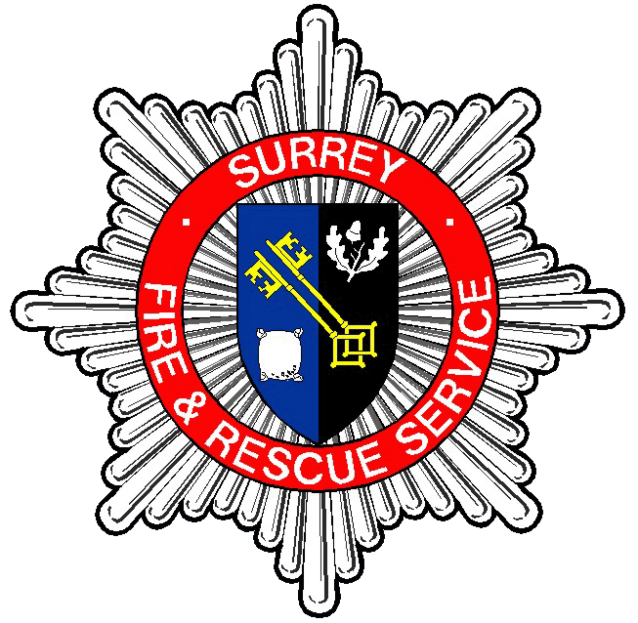

The Role

Group Commander – HMICFRS Inspection and Fire Standards

Department: Performance, Insight and Improvement
Grade/Rank: Group Commander
Responsible to: Head of Performance, Insight and Improvement
Location: Woodhatch Place, Reigate - hybrid
Responsible for: Station Commander – HMICFRS Inspection and Fire Standards,
Business & Project Support Team Leader

Job Purpose:

To protect and save life, property and the environment by contributing to the protection of people and making communities safer by:

- Leading and managing people within their functional areas to create professional, resilient, effective and high performing teams.
- Managing and developing themselves and others to ensure personal and team performance, effective service delivery and achievement of the organisations objectives.
- Managing quality assurance for their functional areas and taking responsibility for ensuring continuous improvement in service delivery and support.
- Managing the efficient and effective use of physical and financial resources to support activities and to achieve the objectives of the business plan.
- Managing service projects in agreement with project plans to meet specified objectives
- Managing information by establishing and maintaining effective communications at all levels, to improve both Service Delivery and Safer Communities and to support and develop organisational goals.
- Building strong and highly effective relationships with partners to deliver collective corporate objectives.

Working within the community to prevent emergencies occurring, minimise their impact when they do and intervene effectively when required. All of this benefitting the community and making Surrey Safer.

Our Core Values and Behaviours:

- Fairness and Respect – We embrace diversity and promote a culture of inclusivity.
- Responsibility – We are answerable for our decisions and actions.
- Professionalism - We will always be the best we can be.
- Honesty and integrity – We are truthful and trustworthy. We do the right thing even if it's not the easiest option.
- Leadership – We choose to lead by example and inspire others in an ethical way.
- Openness – We are open to new ideas.

Our behaviours are what people experience when they interact with us. They encompass how we do our work and how we treat others. We expect all existing and future staff to uphold and promote these Values and Behaviours.

Main Duties and Responsibilities:

- Lead, Manage and support people to resolve operational incidents, swiftly and safely including emergency, critical or major incidents, and other rescue operations. To provide operational leadership at level 3 as well as providing support and mentoring to level 2 officers.

- Implement organisational strategy working with the wider team, creating, implementing and monitoring service plans. This may involve collaboration with internal and external groups and may involve managing change in the station or teams plans following review and consultation with stakeholders.

- Provide structured station and team plans with regular reviews making adjustments as required. Ensure that resources and budgets if held are managed and monitored to support the team plan and if required, make recommendation for improvement.

- Identify development needs in your team using their own role profile against actual performance. Undertake regular supervisions to assess performance in role and align to objectives and targets as set in the annual appraisal. Support them in improving where required using the Service’s Capability Policy where necessary. Coach and mentor your team effectively evaluating your own methods of developing your staff.

- Ensure staff are aware of responsibilities within the station and team plans and allocated work accordingly. Work plans must be SMART. Assess the progress made against these plans at least quarterly and discuss areas for improvement by giving appropriate feedback. Resolve issues of performance following the Service’s Capability Policy.

- Responsible for effective management and timely resolution of people management issues which may include acting as an Investigating Officer or hearing manager. Completing self-service and appropriate service processes where applicable.

- Manage and develop self and others to improve personal and team performance and deliver agreed objectives. Reflect on effectiveness and relationships with your staff to achieve improved performance. Analyse your own working relationships with colleagues and partners and seek feedback as to your performance. Place personal improvement challenges in your own development plan and allow others to contribute.

- Support the AGC in forecasting levels at your stations and lead on Recruitment and Selection for your functional area ensuring all roles have the correct role profile and authorisation to recruit form in place. Ensure that consideration is given as to the best way to replace a vacancy in line with the Services Workforce Resourcing Policy, liaising with HR and Recruitment to establish the best way of attracting, selecting and recruiting to the vacancy.

- Determine effective use of physical and financial resources. Ensure that financial plans are matched with Team and Service Plans. Agree budgets with Area Manager and monitor financial expenditure, reporting deviation accordingly.

- Manage quality assurance for the functional area/s and be responsible for ensuring continuous improvement in service delivery and support.

- Undertake specific projects and investigations as requested. Gather information to support investigations or report findings and conclusions of an investigation and provide written reports as requested by line manager.

- Collect and apply information from various sources to understand station or department performance and identify planning and delivery opportunities and make decisions for continuous improvement.

- Positively contribute to a safe work environment; proportionately apply Health and Safety, Risk Management, Business Continuity and Safeguarding policies and procedures. Process personal data fairly and lawfully as identified within the EU General Data Protection Regulation (GDPR) 2018.

- To actively support safeguarding principles and the embedding of the Service’s Inclusion Strategy.

- To undertake any other reasonable duty, commensurate with the grading and responsibility of the post in order to meet service priorities and business continuity requirements.

The PERSON

Group Commander

Qualifications

Competent in Substantive Wholetime Assistant Group Commander role.
Participate in and pass the core technical and professional development programmes.
Level 5 management qualification or equivalent.
ICS minimum Level 3 qualified.
Requirement to undertake FSC NILO course within the first 6 months of being appointed.
Driving License.

Knowledge and Experience

- Experience of having managed projects and service delivery.
- Experience of having been open and flexible in respect of change, actively participating in devising creative solutions to often complex problems that may occur from time to time and taking people with you on a journey of improvement.
- Experience of having been willing to make decisions and encouraged decision making at the right level reflecting the key priorities and requirements of the organisation, sometimes in complex strategic environment as well as day to day running of the team.
- Experience of having managed complex performance management and absence cases
- Knowledge of the Fire Service Operations and National Guidance (NOG).
- Knowledge of Surreys Values and Behaviours.
- Knowledge of current employment legislation.
- Knowledge of SFRS People Management Policy and Procedures.
- Knowledge of SFRS SOPs.
- Knowledge of SFRS Performance Management framework.
- Knowledge of how to managing resources in practice.
- Knowledge of having managed budgets (SFRS procurement policies).

Skills and Abilities

- The ability to lead by example inspiring, coaching and steering the efforts of those within your team. Motivating them to deliver continuous improvement in everything we do and engage with the Services vision. Engaging external partners that can contribute to the aims of the organisation.

- The ability to adopt different methods and develop innovative ways to gain support and influence internal and external stakeholders to contribute effectively to the aims of the organisation.

- The ability to delegate as required and produce quality output from the stations or teams, allowing others to learn and stretch their own skills while safely achieving the desired outcome.

- The ability to enable self-development to take place, as well as setting and achieving personal goals for the benefit of the stations or teams and the Service as a whole.

- The ability to effectively communicate verbally and in written form to all levels, including senior managers and county councillors. Utilising diverse and innovative methods to communicate the service vision and to engage internal and external stakeholders to work collaboratively to improve service delivery.

- The ability to work in an organised way to ensure efficient operating processes within your team, managing priorities and deadlines.

- Ability to work effectively with technology and able to demonstrate competence with basic software or IT equipment.

- Ability to consistently projects and promotes a confident, controlled and focused attitude in highly challenging situations

Other
- Understanding of and commitment to Inclusion & Equality in the workplace.

