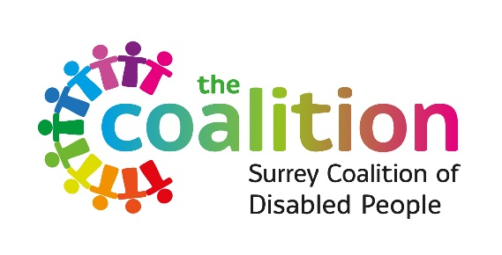

POST: Social Media and Digital Officer
HOURS: 18 – 21 hours per week
TERM: Fixed term contract for 6 months, with the possibility of extension subject to securing funding
SALARY: £25,000 – £26,000 per annum (FTE)
LOCATION: Hybrid role: Homebased with travel within Surrey or office based at our office in Burpham.
REPORTING TO: Digital Communications Coordinator
ACCOUNTABLE TO: Surrey Coalition Board of Directors

Who we are:
Our vision is a world where difference is valued, and diversity is celebrated. A world where everyone has the same rights, freedoms, choices, and opportunities.
Surrey Coalition of Disabled People is an innovative organisation that is led by disabled people working together to achieve our vision.

Introduction to the role
We’re a vibrant, forward-thinking team that believes digital communication should drive awareness, inspire connections, and share the experiences of our members. If you thrive on creativity, love technology, and enjoy creative writing, this role is for you!

Purpose of the role
We want to expand our reach and increase our engagement. You will help us to achieve this through managing our social media channels as well as drafting blogs and keeping our website up to date

Main responsibilities
- Craft/develop content for the Coalition’s social media channels and website
- Co-ordinate and develop an ongoing schedule of new content for each of the social media platforms, ensuring this is in line with the overall organisation’s activities
- Monitor networks/trending topics to ensure that the Coalition maximises any opportunities to respond to appropriate topics
- Provide analysis of the effectiveness of our content through regular reporting including key metrics such as reach, impressions and engagement
- Keep the website updated – including making changes to pages as well as building new ones

We are looking for someone with:
- Outstanding organisation and planning skills (E)
- Excellent written communication skills and experience with copywriting for social media platforms (E)
- Some experience of creating and editing basic graphics, video and animation using software such as Photoshop, Illustrator, Canva, Adobe Effects and/or photo editing software (E)
- Some experience of editing web pages and building web pages (E)
- Able to analyse and evaluate reports from social media activity (E)
- Experience of working in a Disabled Peoples Organisation or in the wider Voluntary Community and Social Enterprise (VCSE) sector (D)
- Experience and knowledge of working with people who are Disabled and/or carers or lived experience of Disability or being a family Carer (D)
- Experience of developing accessible digital communications (D)

To apply please fill in the application form and send it to info@surreycoalition.org.uk
CVs will not be accepted.

Closing date is 17th October 2025 at 5 pm

September 2025

